The Lower Mainland Purpose Society
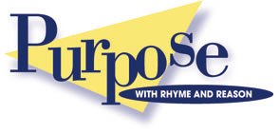
Fall 2013

Parenting Groups & Programs
Daytime Programs:
Parent & Caregiver Support Programs – with children under 6 years of age:

F.L.Y. – Fun, Learning & You! For parents/caregivers with children 2 – 5 years
Sept 17-Dec 3, 2013 Tuesdays: 10 a.m. – Noon (registration required)
New West residents only

E.M.E. – English Made Easy For non-English speaking parents/caregivers and children under 6 years
Sept 11-Dec 18, 2013 Wednesdays: 10 a.m. – Noon (registration required) New West residents only Queensborough Community Center

- To register for FLY Call Josie or Pam 604-526-2522
- To register for EME Call Pam or Janice 604-526-2522

- FLY is held at the Lower Mainland Purpose Society located at 40 Begbie St, New West

- English Made Easy is held at Queensborough Community Center, New West

- All Programs are FREE and funded by CAPC, Success by Six, Children First and MCFD

